🍪 picoCTF: Cookies Write-up

Challenge Overview
- Category: Web Exploitation
- Description: "Who doesn't love cookies? Try to figure out the best one."
- Objective: Find the specific cookie value that triggers the server to return the flag.
Initial Reconnaissance
Upon visiting the provided URL, you're greeted with a simple search bar. The placeholder suggests "snickerdoodle."
- Step 1: Enter "snickerdoodle" into the search box.
- Result: The page redirects to /check and says: "That is a cookie! Not very special though."
- Step 2: Open your browser's Developer Tools (F12) and navigate to the Application (or Storage) tab.
- Finding: Look at the Cookies for the site. You’ll notice a cookie named name with a value of -1.
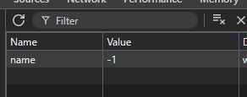
Vulnerability Analysis
The application uses the name cookie to determine which "cookie page" to display.
- If name=-1, it shows "snickerdoodle."
- If you change name to 1 and refresh the page, it shows a different cookie (like "chocolate chip").
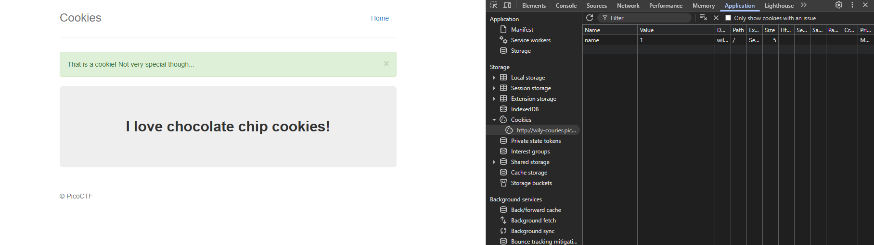
The Exploit

Since the value is -1 its kinda suspicious so I tried to change the value to 1 then refresh the page then it change so I change value until the 18th value it gave me the flag
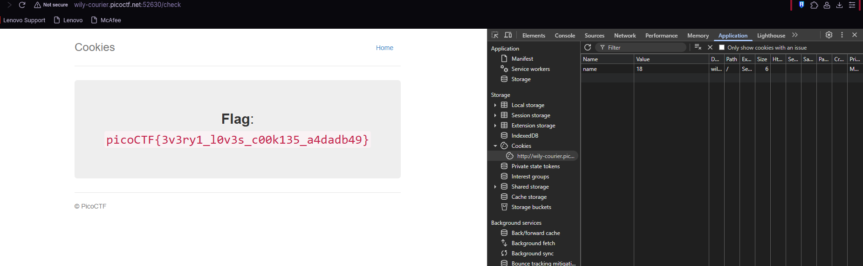

FLAG: picoCTF{3v3ry1_l0v3s_c00k135_a4dadb49}

